1. Aboveground biomass should came from Fig. 2, however data from Fig. 2 doesn’t match the data on the master sheet.

Meng was not able to find the hi/low and avg data for aboveground biomass. This data is from tab "salt marsh biomass", row 11.

***[Response from Blanca]*** *I have no idea, I didn’t add this paper. It looks like what you should use is the data from live biomass of the “C” plots only, above and below. Maybe the high and low are the highest and lowest biomass in all these treatments, but we don’t want that anyway and it is misleading. Use the live data from the C plots only.*

According to Blanca’s response, we only use the above-and belowground biomass from C (control) group.

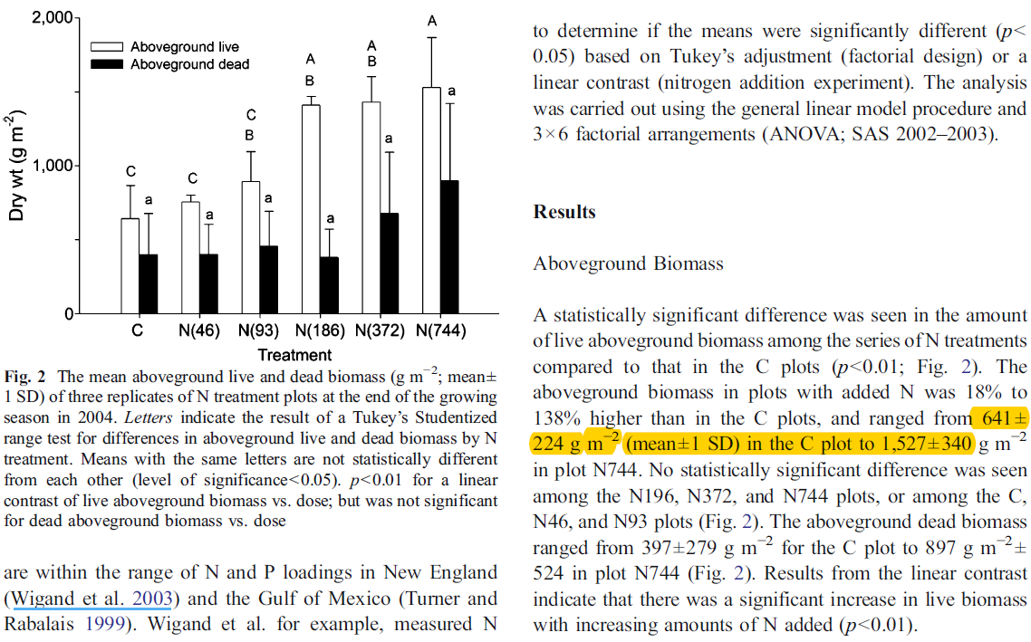

2. Belowground biomass should came from Fig. 6, 7, however data from Fig. 6, 7 doesn’t match the data on the master sheet.

